Ideation Phase
Brainstorm & Idea Prioritization Template
Date | 10 July 2026
Team ID | Geeta Rani
Project Name | ShopEZ
Maximum Marks | 4 Marks

Brainstorm & Idea Prioritization Template

Step-1: Team Gathering, Collaboration and Select the Problem Statement
ShopEZ is an online e-commerce application built on the MERN stack that enables customers to discover products, manage a shopping cart, and check out securely. This application was developed by one person in his/her capacity as an individual project. The problems encountered in this domain included scattered product discovery across multiple platforms, cumbersome cart management, and the absence of a lightweight, secure way to register, log in, and track a shopping session without depending on a large third-party marketplace.
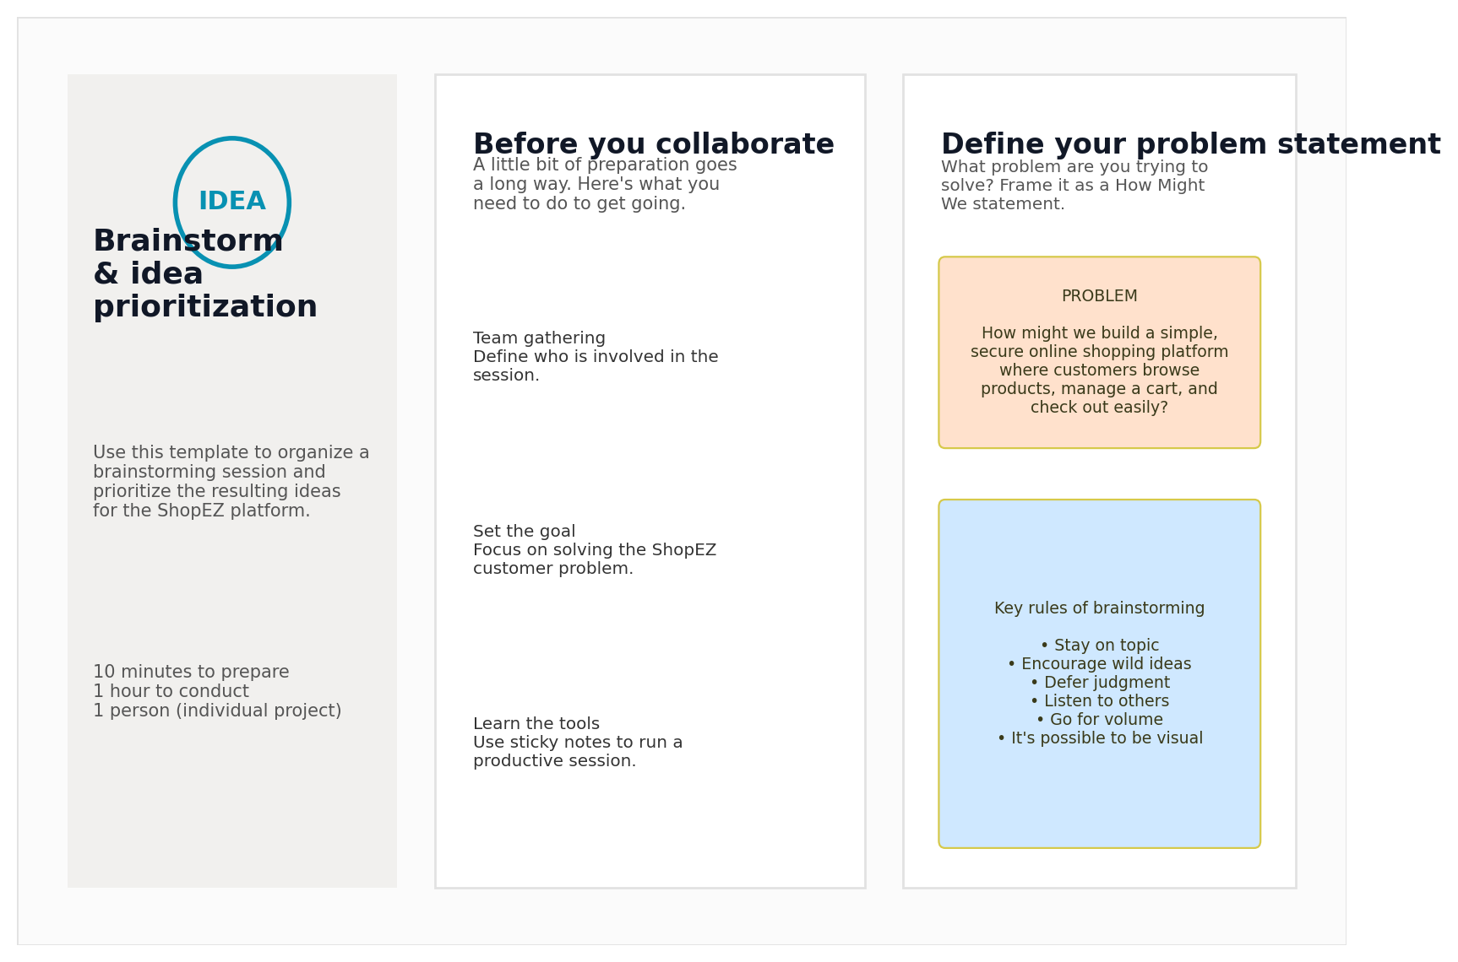

Step-2: Brainstorm, Idea Listing and Grouping
A total of 10 ideas were generated to address the above-stated problem. They were grouped under the headings of Product Catalog Module, Cart Management Module, User Authentication Module, and Currency & Checkout Module.
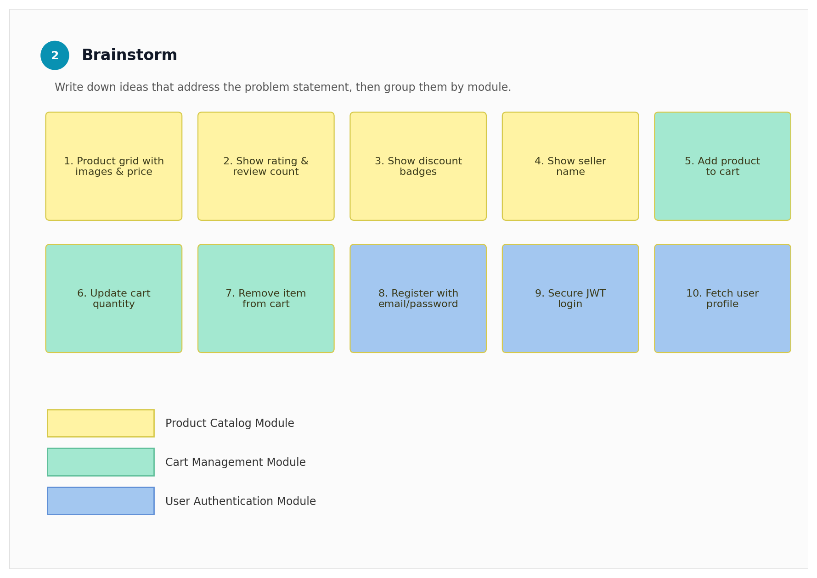

Step-3: Idea Prioritization
All 10 brainstormed ideas were prioritized according to their significance and practicality. Core features including product browsing, add-to-cart, user registration, login, and JWT authentication were assigned a high priority rating. Cart quantity updates and multi-currency display were considered medium priority. Planned improvements such as payment gateway integration, order tracking, wishlists, and product reviews were assigned a low priority rating and will be incorporated in future versions of the application.
Priority | Ideas
High | Product browsing, Add to cart, Customer registration, Login, JWT authentication
Medium | Cart quantity update, Multi-currency price display
Low (Future) | Payment gateway, Order tracking, Wishlists, Product reviews

Conclusion
This brainstorming and idea prioritization exercise formed the foundation for the ShopEZ product roadmap. High-priority ideas were carried forward into the Project Design and Project Planning phases, where they were translated into a solution architecture, user stories, and a sprint-wise development plan.

